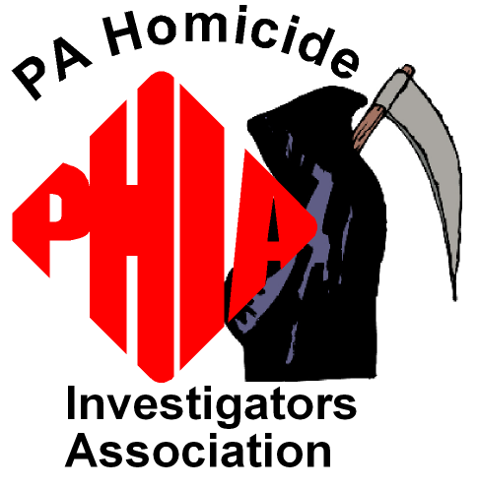
PENNSYLVANIA HOMICIDE
INVESTIGATORS ASSOCIATION

2015 SPRING TRAINING CONFERENCE

The Pennsylvania Homicide Investigators Association is hosting a training conference for law enforcement officers and their affiliates. This year we are featuring the one-week ADVANCED PRACTICAL HOMICIDE INVESTIGATION® SEMINAR presented by Lt. Commander (Retired) Vernon J. Geberth, President of P.H.I. Investigative Consultants along with three additional speakers; Dr. Wendy Lavezzi, Forensic Pathologist, Lt. Tracy Harpster, Moraine, Ohio PD and Ms. Andrea Zaferes, Forensic Aquatic-Death Investigator.
Topics covered by our four featured speakers include Advanced Investigative Tactics, Procedures and Techniques, Sex Related Homicides, Lust Murders, Suicide and Equivocal Death, Deviate Sexuality, Crime Scene Investigation, Pathology and Autopsy Section, Analysis of 9-1-1 calls, and Homicidal Drowning Investigation. For additional information about this curriculum please visit (www.practicalhomicide.com) or (www.pahia.us)

Date: April 13 through April 17, 2015. (Monday – Friday)
Registration: Monday (04/13/15) from 7:30AM to 8:00AM
Instruction Period: 8:00AM to 5:00 PM

Location: Ramada Inn and Conference Center (www.ramadasc.com)
1450 South Atherton Street
State College, PA 16801 (814) 238-3001

Accommodations: A block of rooms has been reserved for those attending the PHIA conference. Individuals are responsible for making your own reservations. Our rate is $71.00+tax per night. Deadline for this rate is 04/08/15.

Conference Fee: Cost for the five-day conference is $635.00 per person.
This includes five days of top notch instruction as well as applicable hand out materials. PHIA membership fee is included in the seminar package cost. Early applications are encouraged due to space limitations (100 attendees).

Registration: Please send the registration form and the checks to the training coordinator. Deadline for registration is April 08, 2015. Checks should be made payable to P.H.I.A.

Training Coordinator: Thomas N. Jordan (PHIA Treasurer)
District Court 49-3-04
2795 Earlystown Road
Centre Hall, PA 16828

Meals: Continental breakfast and mid-morning and afternoon
refreshments are included with seminar costs.
Lunch and dinner not included.

P.H.I.A. REGISTRATION FORM
ADVANCED PRACTICAL HOMICIDE INVESTIGATION
FIVE DAY SEMINAR
April 13 – April 17, 2015

Ramada Inn and Conference Center
1450 South Atherton Street
State College, PA 16801
(814) 238-3001

$ 635.00 Per Person -Includes P.H.I.A. Dues for 2015 and Lt. Cmdr. Geberth’s Sex-Related Homicide and Death Investigation Text Book

FULL NAME:_________________________________________________

TITLE/RANK:________________________________________________

DEPARTMENT / TROOP:______________________________________

UNIT:________________________________________________________

WORK ADDRESS:____________________________________________

CITY:___________________________STATE:__________ZIP:_______

WORK TELEPHONE WITH AREA CODE:______________________

WORK FAX NUMBER:_______________________________________

PAGER NUMBER WITH AREA CODE: ________________________

E-MAIL ADDRESS:
(PHIA EIN # 47-2400053)

MAIL APPLICATIONS TO: Thomas N. Jordan, PHIA
District Court 49-3-04
2795 Earlystown Road

Centre Hall, PA 16828
Phone: (814) 364-1492
E-mail (tomjordan129@yahoo.com)

CHECKS OR PURCHASE ORDERS ONLY PAYABLE TO P.H.I.A.

This is the only time the Advanced Practical Homicide Investigation® will be held in the northeast in 2015.
Tuition includes membership into Pennsylvania Homicide Investigator’s Association and Lieutenant Commander Geberth’s book SEX-RELATED HOMICIDE AND DEATH INVESTIGATION: PRACTICAL AND CLINICAL PERSPECTIVES, SECOND EDITION.

ANDREA ZAFERES
Forensic Aquatic-Death Investigator & Expert Witness
Medicolegal Investigator
Homicidal Drowning Investigation
Team Lifeguard Systems, Inc.

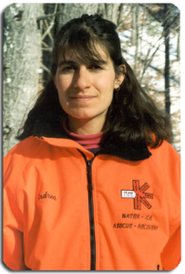

Andrea Zaferes serves as a medicolegal investigator for Dutchess County in New York State. She is also Vice President of Lifeguard Systems Inc. and RIPTIDE Inc. Ms. Zaferes serves as a course director and instructor trainer and is a well published author and noted public speaker and award winner, As a program designer, Andrea Zeferes is one of the leading trainers in the international water rescue and recovery industries today.
Andrea graduated from University of Michigan with a BA in Psychology and has completed numerous courses in basic death investigation and is a graduate of the Master’s Conference in Death Investigation, St Louis University. Andrea has been certified in numerous states and has been presenting forensic training since 1999 throughout the United States and Canada. She has also taught in Puerto Rico, Asia, The Caribbean and Costa Rica.
Andrea Zaferes has investigated and worked on more than 30 scuba accident and fatality lawsuits and has consulted on more than 150 water related death cases. She is an Expert Legal Witness for diving and other water-related incidents and assists law enforcement in homicidal drowning investigations.
Andrea Zaferes has published extensively in both journal articles and textbooks and has over 100 publications based on her research and experience.

Tracy Harpster, M.S, B.S., FBINA

Lieutenant Moraine, Ohio Police Department
tharpster@moraineoh.org
(937) 535-1153
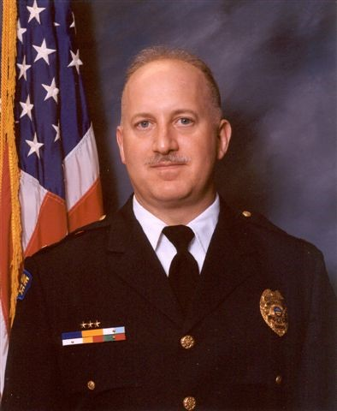

Lieutenant Tracy Harpster is a thirty-year veteran of the Moraine, Ohio Police Department and a graduate of the FBI National Academy. He has served as a patrolman, Sergeant, Detective Sergeant and Lieutenant in various assignments including supervising the Tactical Crime Suppression Narcotics Unit, The FBI Joint Terrorism Task Force and the Ohio Organized Crime Investigations Commission.

Lt. Harpster has a Master’s of Science in Criminal Justice from the University of Cincinnati and Bachelor of Science in Criminal Justice from Bowling Green State University and is a 2004 Graduate of the FBI National Academy in Quantico, Virginia.

Lt. Harpster is a nationally renowned authority and has published extensively on the analysis of
9-1-1Calls. Lt. Harpster and Dr. Adams have co-authored an article entitled , “911 Homicide Call and Statement Analysis: Is the Caller the Killer?” in multiple publications. In 2013, Lt. Harpster was accepted as a member of the Vidocq Society, a crime-solving organization that meets monthly at the Union League of Philadelphia

In 2006, Lieutenant Harpster achieved a Graduate Degree from the University of Cincinnati where his Master’s Thesis examined the indicators of innocence and guilt of 911 homicide callers reporting the offense. The study defined and analyzed the indicators in order to assist homicide detectives gain insight into the offense, suggest offender probability, and explore pertinent issues during the interview and interrogation phases of the investigation.

Lieutenant Harpster has directly assisted on over 500 homicides and has analyzed over nine hundred 911 homicide calls, using the research to help solve the murders. Lt. Harpster has shared his research at homicide conferences across the country including the National Homicide Conference (2006, 2008, 2012, and 2014) and the International Homicide Conference (2010).

