Legalize weed: Gov. Wolf says that’s the way to repair economy crushed by coronavirus
Sam Ruland
Beaver County Times
8/26/2020
Calls to legalize weed and create a new source of revenue have taken on fresh urgency as Pennsylvania faces a years-long financial crisis following the coronavirus outbreak.
Gov. Tom Wolf is calling on the Pennsylvania legislature to legalize recreational marijuana and use the tax revenue to help small businesses that have been impacted by the coronavirus pandemic.
The pandemic has steered Pennsylvania’s economy into a recession. And although programs such as the Pandemic Unemployment Assistance and the Paycheck Protection Program have helped some, Wolf said, more needs to be done.
"Repairing the damage of this pandemic is not going to be easy," Wolf said at a news conference Tuesday. "The legislature can act right now to get us back on track as quickly as we possibly can."
He wants to see more money provided to front-line workers and working parents, and be used to create more grants to support small businesses.
Wolf said the government could fund these efforts with the $1.3 billion it has left from federal coronavirus stimulus relief and from the revenue from legalization of recreational marijuana.
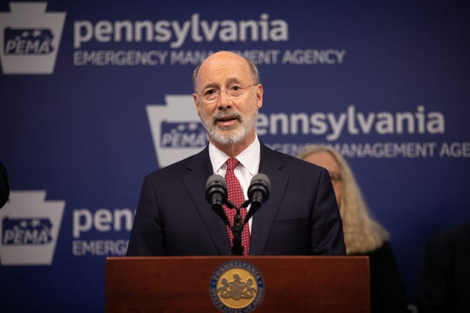
Pennsylvania created infrastructure to begin regulating the medical marijuana industry when the Legislature passed bills to oversee and tax medical weed in 2016. And since then, Wolf and Lt. Gov. John Fetterman have been vocal about their support for full legalization in Pennsylvania.
Eleven states have already legalized marijuana for adult use, and Senate Bill 350, which has come to be known as the "gold standard" legalization bill, is ready and waiting for Pennsylvania's legislature to act on it.
But this industry is no stranger to delays, and lawmakers failed to pass similar bills before.
"The inclusion of cannabis legalization in Governor Wolf’s Fall agenda today doubles down on the Wolf Administration’s commitment to encourage and support statewide legalization in Pennsylvania," said Jeffrey Riedy of the Lehigh Valley chapter of NORML, the National Organization for the Reform of Marijuana Laws.

The voice of the opposition
However, not everyone was on board with the governor's plans. House Majority Leader Kerry Benninghoff, a Republican from Centre County, was dismissive of the proposals, and questioned Wolf's motives.
"It is disingenuous for this governor to put forward an unaffordable legislative agenda and require taxpayers to bail him out of his unilateral mandates that have devastated their lives and livelihoods," Benninghoff said in a statement.
He said a House session next week will focus on "finding the normalcy Pennsylvanians have long desired."
Scott Bohn, executive director of the Pennsylvania Chief of Police Association, also expressed his concerns with the governor's announcement today. He said legalization of marijuana could pose significant challenges for law enforcement resulting from the unanticipated consequences it has on crime and public safety.
It is unclear how much revenue could be raised by cannabis sales. Dated estimates said the state could see hundreds of millions in taxes. Others guess the industry, which will create jobs that stretch beyond dispensaries, could have a larger impact.
Wolf's past budget proposals, when he thought the state could see marijuana purchases in 2018 and 2019, put the first-year figure around $60 million and then $80 million for both medical and adult use.
But obviously, the state never saw a penny from legal weed sales as lawmakers never passed a bill legalizing recreational-use marijuana.

