Wilkes-Barre settles retaliation lawsuit with police union
- By JAMES HALPIN STAFF WRITER
Aug 12, 2020 Updated Aug 12, 2020

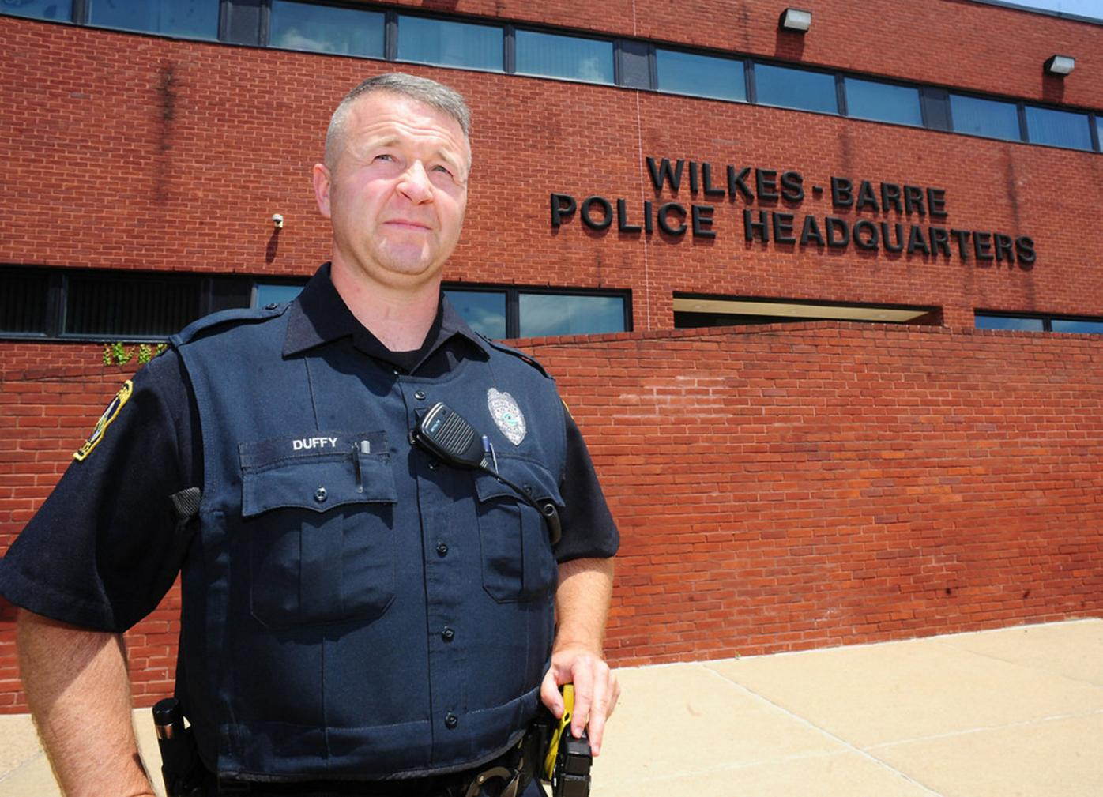

Two former Wilkes-Barre Police Department union officials have reached a settlement with the city in a federal civil rights lawsuit alleging they were retaliated against for expressing their First Amendment rights.
In January 2018, then-union president Phil Myers and then-vice president Dan Duffy filed suit alleging they faced disciplinary action in response to criticisms leveled against the city and police administration, including posts on the union’s Facebook page, which they asserted were done in their capacities as union officials.

In an order filed Tuesday, U.S. District Court Judge Jennifer P. Wilson ordered the case administratively closed and directed the parties to consummate the settlement within 60 days.
Court documents do not provide details about the settlement.

Plaintiffs’ attorney Mark B. Frost of the Philadelphia law firm Mark B. Frost & Associates said the settlement contained a confidentiality clause that prohibited him from disclosing the terms.
“The case was settled to the mutual satisfaction of all parties,” Frost said.
Myers was demoted and suspended during the tenure of Mayor Tony George, police Chief Marcella Lendacky and Commander Ron Foy. Duffy was suspended and then later fired for allegedly sending a threatening email to George and his city administrator.
A copy of the email attached as an exhibit to court documents shows Duffy described Foy as acting in a manner that was “unprofessional, inappropriate, and insulting to the profession.”
The email goes on to say the union maintained a list of Foy’s conduct and that “your failing to act on a ‘problem laying in wait’ may be a costly one, both tangibly and intangibly.”
While city officials cast the email’s tone as threatening, the union alleged it was protected by the freedom of speech.
Duffy was reinstated in October 2018 after the union and city settled a grievance.
In an order filed in March, Wilson threw out the case against the City of Wilkes-Barre but allowed the matter against George, Lendacky and Foy to proceed.
“Although defendants deny that there was a causal connection linking the allegedly retaliatory conduct to much of plaintiffs’ speech, they acknowledge that the plaintiffs were disciplined because of their Facebook posts,” Wilson wrote. “Therefore, because there was a causal connection between the plaintiffs’ posts on the union Facebook page — which, as previously discussed, were constitutionally protected speech — and defendants’ allegedly retaliatory conduct, there is sufficient evidence for a reasonable factfinder to find causation.”
Following the release of a report from the Pennsylvania Chiefs of Police Association that was critical of their leadership, Lendacky retired and Foy’s commander position was eliminated and he returned to his detective job.
George Brown roundly defeated George to become mayor during the May 2019 primary election.
Myers and Duffy remain employed by the department.
Contact the writer:
jhalpin@citizensvoice.com

