Reform, don’t defund, the police. This is why | Opinion
By
Capital-Star Op-Ed Contributor
-
July 10, 2020
By Scott L. Bohn

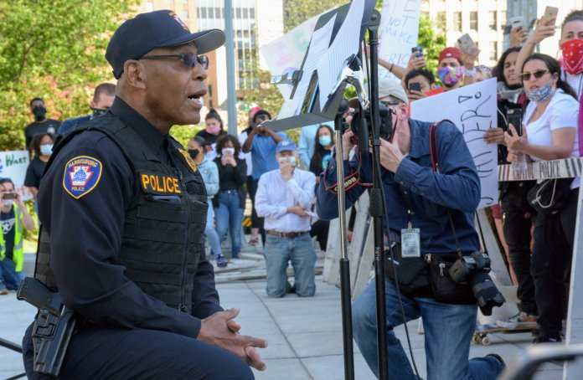
Harrisburg police chief Thomas Carter kneels in front of angry protesters on June 1, 2020, who riddled him with criticisms of a police conduct during a Black Lives Matter protest Saturday. (Capital-Star photo by Stephen Caruso)
Defunding or re-appropriating law enforcement funding is an impulsive, counterproductive approach to addressing issues that require a systemic set of solutions.
“Defunding police” means something different to everyone, but the common theme involves cutting funding from police department budgets.
Encouraging and embracing systemic reforms, improving police training, policies, procedures, and technology requires financial resources and a sustained commitment from our police leaders, our elected officials, and our community members.
The defunding and reallocation of resources away from the police will further reduce the ability of law enforcement leaders to implement the positive changes that are appropriately being called for and now being legislated. Now is not the time to reduce the capacity of police agencies to connect with their communities and provide services to those who are most in need of assistance and protection.
Support for defunding is far from unanimous. Approximately 7 in 10 Americans are “very” or “somewhat” satisfied with their local police, according to Monmouth University polling.
The incidents that have occurred in our country should not impair the progress that has been made or obstruct the work that must be done to combat injustice and violence in our state. The concept of social justice is not isolated to policing or Pennsylvania.
This is an issue that is also rooted in:
- Employment
- Equal opportunity
- Education and vocational training
- Health care
- Mental health services
- Social services
- Food insecurity
- Housing/Homelessness
- Substance Abuse – recovery services
- Reductions in state and local budgets (pandemic)
- Civility, common courtesy, and a respect for human dignity
By default, police agencies have been required and otherwise mandated to fill the voids which exist. This places law enforcement in an untenable position. While there is a need to provide additional fiscal and human resources to each of these problems, fulfilling this void should not come at the expense of police funding.
Law enforcement remains the only entity of government that consistently responds to every situation where immediate help is needed.
In an already underfunded profession, resources should not be taken away from law enforcement, but rather, additional resources should be identified and provided to the areas of need. Reducing financial support and risking public safety in our communities is not a practical solution.
In an idealistic society, it may a good concept, but issues must be examined through the lens of truth and realism. At both the federal and state levels of government, we cannot have the often-predictable dichotomy of “all or nothing” legislation. There must be an accompanying message to the public to reassure them that crime and public disorder will be addressed and crime victims supported.
I hear and recognize the frustration, emotion, and anger behind the current movement. I watched the entire 8 minutes and 46 seconds of George Floyd’s agonizing death under the knee of a Minneapolis police officer who was alleged to have had numerous prior complaints of excessive force.
I also recognize the difficulty of serving the public with a financially weakened and disheartened police department. With less funding, there will likely be large layoffs. An overwhelmed and smaller agency may end up doing more harm than good. The number of potential applicants will likely decrease, as very few people will want a job that does not pay well and is subjected to great personal and professional risk.
I believe, and polling suggests, that those who argue for defunding police actually want reform and good policing.
We endorse the Pennsylvania Law Enforcement Accreditation program, ensuring that agencies and their policies reflect the most modern and progressive 21st-century policing practices that promote community trust and accountability. Federal and state aid to police should be conditioned and/or based on whether basic standards and practices have been met.
Law enforcement is a noble profession. The Pennsylvania Chiefs of Police Association supports the professional men and women who honorably serve their communities.
The incidents that have occurred in our country and in our commonwealth should not damage the progress that has been made or obstruct the work that must be done to combat injustice and violence in our state. Pennsylvanians need to come together and work against social injustice and make our Commonwealth equally safe for all its citizens. The first responsibility of government is public safety. “Defunding police” is not a viable or practical solution.
Scott L. Bohn is the executive director of the Pennsylvania Chiefs of Police Association. He writes from Harrisburg.

