Former West Chester police chief calls for Police hiring reform
- MediaNews Group, Jun 14, 2020

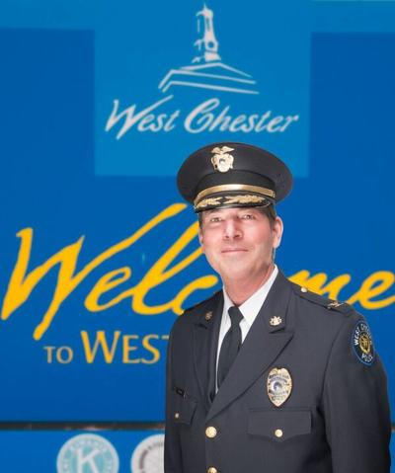
West Chester Police Chief Scott Bohn is retiring.
SUBMITTED PHOTO

WEST CHESTER—The Pennsylvania Chiefs of Police Association formally joined the coalition formed by Attorney General Shapiro to end the practice of law enforcement agencies unknowingly hiring officers with documented patterns of excessive use of force or other misconduct.
“The Pennsylvania Chiefs of Police Association, (PCPA), appreciates the invitation to support and join a coalition to end the practice of law enforcement agencies unknowingly hiring officers with documented patterns of excessive use of force or other misconduct,” said Scott Bohn, former West Chester police chief and Executive Director of the Pennsylvania Chiefs of Police Association.
“We appreciate Attorney General Shapiro for his leadership in conducting this essential work and ensuring that Pennsylvania’s law enforcement executives and leaders have a seat at the table.
The PCPA supported a statewide registry when it was introduced in 2016. The PCPA has long supported this policy so Pennsylvania police departments can certify it hiring practices. The Pennsylvania Chiefs were a critical part of discussions with lawmakers in 2019 and are at the forefront in moving professional law enforcement forward,” Bohn said.
The PCPA’s mission is to assist and support Pennsylvania police departments in attaining the highest level of professionalism. As an Association of police leaders, we are committed to providing our members with guidance on best practices and policy.
We have long recognized that police officers who engage in misconduct or use excessive force erode trust in law enforcement and make it harder for our communities to be and feel safe. The PCPA has worked assiduously to reduce inequality in any form within our Commonwealth. In our view legislation is not only necessary, but the appropriate thing to do.
It is our continued obligation to confirm our stated values, our oath, our sworn duty and our responsibility for the protection and inviolability of human life and service to the citizens of Pennsylvania.
We will continue to work with all our law enforcement partners, Associations, and leaders in the coalitions to support legislation to accomplish this reform,” concluded Bohn.
“The Pennsylvania Chiefs of Police Association is one of the strongest law enforcement organizations in the Commonwealth, and supported a registry years ago. We couldn’t have formed such a strong statewide coalition without their help,” ​said Attorney General Shapiro. ​“Having PCPA at the table is crucial and will help make this critical reform a reality in Pennsylvania.”
The group consists of: Philadelphia Police Commissioner Danielle Outlaw, Pittsburgh Police Chief Scott Schubert, FOP Lodge 5 President John McNesby, President of the Pennsylvania State Lodge FOP Les Neri, Pennsylvania District Attorneys Association, Pennsylvania State Troopers Association, and now the Pennsylvania Chiefs of Police Association.
The group states, “Officers who engage in misconduct or use excessive force erode trust in law enforcement and make it harder for our communities to be and feel safe. When they leave an agency, or retire in lieu of termination, that record needs to go with them. We stand united in calling for reform of the hiring process so that law enforcement agencies have the information to make informed decisions about the personnel they hire.”
Interdepartmental police hiring reform has been called for by experts and grassroots community groups as well as the State Legislature Police Reform Working Group, and has recently been introduced at the federal level.

