FEATURED

NEPA police departments lacking diversity
- By JAMES HALPIN AND TERRIE MORGAN-BESECKER STAFF WRITERS
Aug 30, 2020 Updated Aug 30, 2020

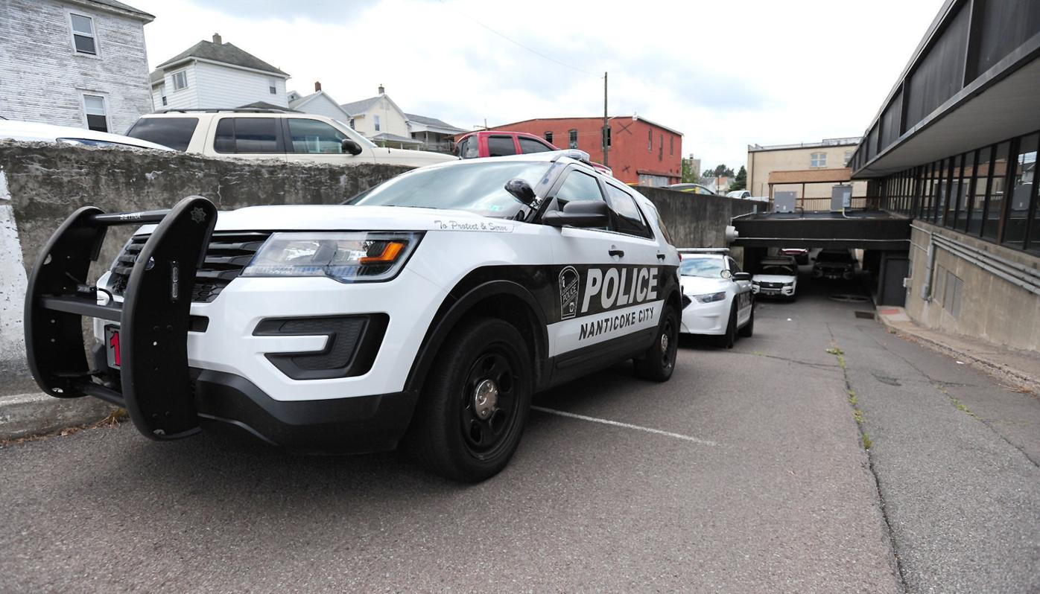

Nanticoke City Police cruisers sit in the driveway of the police station behind the city’s municipal building. The city’s police department is all white and does not include any Spanish-speaking members, which Mayor Kevin Coughlin acknowledges ‘should be addressed.’
- MARK MORAN / STAFF PHOTOGRAPHER

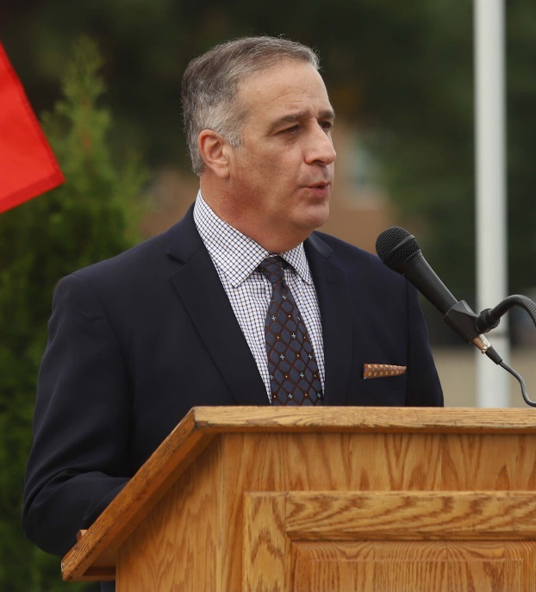
Pittston City Mayor Michael Lombardo

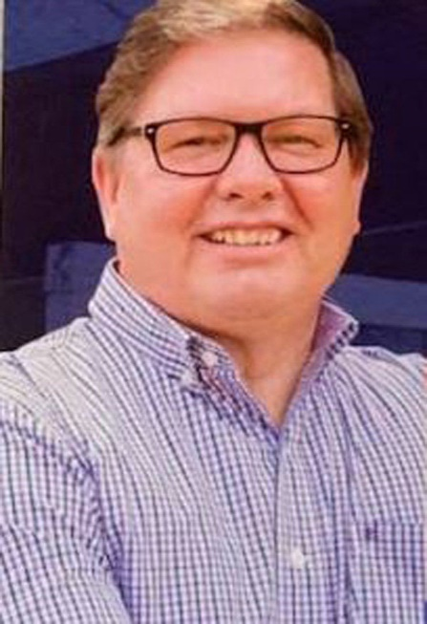
Nanticoke mayor Kevin Coughlin

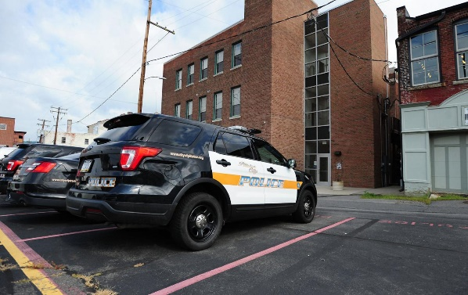
Pittston City PD

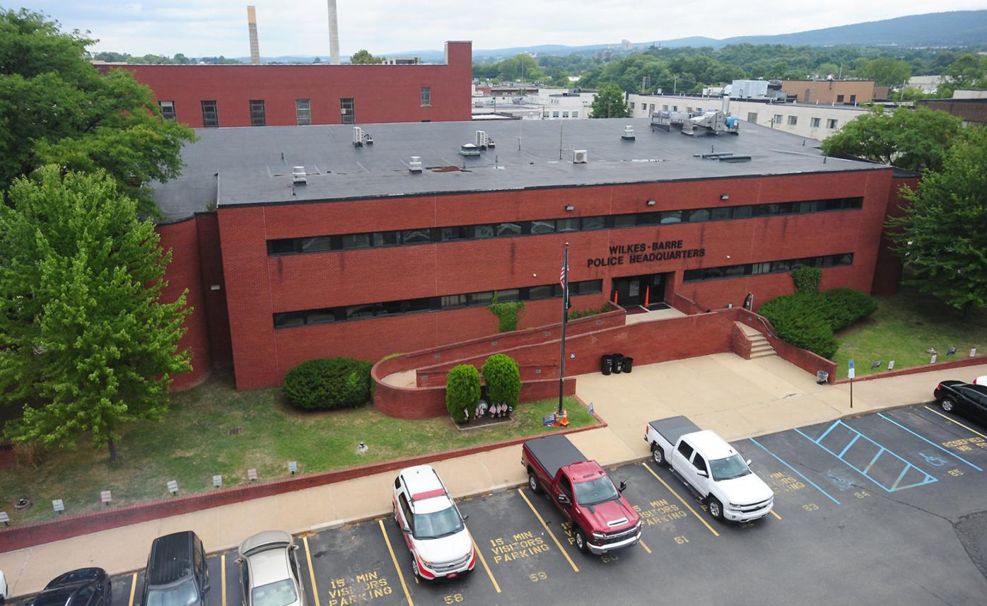

Wilkes-Barre City PD

City police departments in Luzerne and Lackawanna counties are overwhelmingly staffed by white officers at rates disproportionate to the communities they serve and to similarly sized cities throughout the state.
Departments in Wilkes-Barre and Scranton report whites make up about 97% of their staff, despite the fact that they account for 73% and 84% of their respective populations.
Hazleton, with nearly 57% Hispanic and 9% Black residents, has just one Black and four Latinx officers on its 39-member police force.
In the region’s three other cities — Nanticoke, Pittston and Carbondale — the police departments have no Black or Hispanic full-time officers; Carbondale does employ three Hispanic officers and one Black part-time officer. The three cities’ populations are about 93% white.
The local Pennsylvania State Police barracks also are almost entirely white. In Troop P-Wyoming, which covers Bradford, the northern part of Luzerne, Sullivan and Wyoming counties, just 2.5% of the 158 troopers are minorities. Troop N-Hazleton, which covers Carbon, Columbia, the southern part of Luzerne, and Monroe counties, is more diverse. Of the 248 troopers, 6.4% are minorities. But in Troop R-Dunmore, which covers Lackawanna, Pike, Susquehanna and Wayne counties, just 1.2% of the 169 troopers are minorities.
Wilkes-Barre’s 78-member force has two Hispanics, accounting for about 2.5% of the officers. It employs no Black officers, although one member of the civilian staff is Black. In Scranton, just four of the 145 officers or 2.7% of the force, are minorities — three Black officers and one Hispanic.
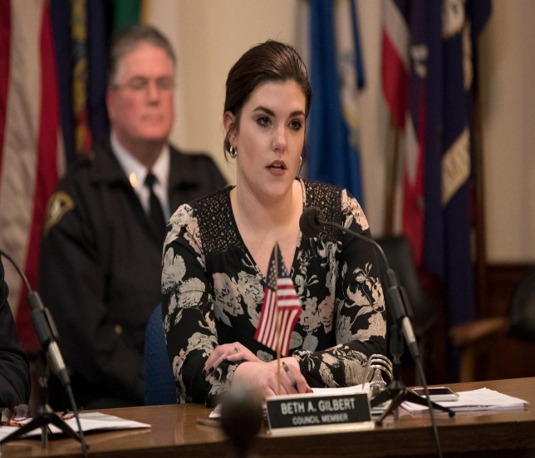
Wilkes-Barre Councilwoman Beth Gilbert McBride
THE CITIZENS’ VOICE FILE
“That is obviously concerning for a number of reasons, as our department should reflect the diversity of our community to improve community relations,” Wilkes-Barre Councilwoman Beth Gilbert McBride said of the city police department’s 97% white staff. “It is so important for children in our community to see police officers who look like them to help build that positive relationship.”
Hazleton’s police department has the highest percentage of Hispanic officers among Northeast Pennsylvanian’s five cities — about 10% of its force. But those four officers are the only ones on the force that are bilingual in a city that has a majority Hispanic population.
“That causes a problem,” said Angel Jirau, founder of Spanish American Leaders Serving All. “When you have people that can speak the language, look like the community, it’s just more effective.”
While other similarly sized police departments across the state also have disproportionate Black and Hispanic representation compared to their overall populations, many do employ minorities at significantly higher rates than the cities in Luzerne and Lackawanna counties.
Bethlehem’s population, for instance, is about 8% Black and 29% Hispanic. Its 154-member police department employs 12 Hispanics, five Black officers and one Asian officer, which represent about 12% of their force.
Reading and Harrisburg, which have a significantly higher minority populations than Scranton and Wilkes-Barre, also employ more minorities on their police forces. Reading, with about 12.3% Black and 66% Hispanic residents in its 88,375 population, has about 20% minorities on its police force. Harrisburg, with about 52% Black and 22% Hispanic of its 49,271 residents, has about 16% minorities on its force.
Nationwide, police departments have succeeded in attracting more Hispanic officers, but continue to struggle to attract Blacks, statistics show.
In 1997, just 7.8% of officers nationwide were Hispanic, according to the federal Bureau of Justice Statistics. That increased to 12.5% as of 2016, the latest data available. The number of Black officers decreased slightly from 11.6% in 1997, to to 11.4% in 2016.
A lack of diversity has been a longstanding issue for departments nationwide, but it has taken a renewed urgency in the wake of the nationwide Black Lives Matter protests.
“In all the years I’ve worked with civil rights, I’ve never seen our nation so divided on racial lines,” Jirau said. “And it’s more dangerous than I’ve ever seen. To look at young people’s eyes and how full of hate, that I’ve not seen in years. That’s terrifying me. That’s the enemy we have.”
Scott L. Bohn, executive director of the Pennsylvania Chiefs of Police Association, acknowledged the recent civil unrest has had an impact on minority recruitment.
“Certainly, I think that the current climate has made it a bit more challenging,” he said. “I think the challenge in the Northeast is probably not much different from the challenge all across the commonwealth. I think it’s fairly representative.”

Multiple factors
The lack of diversity in local police departments is tied to multiple factors, some financial, some demographic and some societal, local officials said.
In Carbondale and Pittston, officials said the issue is primarily demographics.
“Our population is not very diverse, so our pool to pick from is very limited,” said Carbondale Police Chief Brian Bognatz.
Bognatz and Pittston City Mayor Michael Lombardo also noted the departments are small. Carbondale has just 10 full-time and five part-time officers, while Pittston has eight full-time and four to eight part-time officers.
Lombardo said many full-time officers in his city stay on the force for decades and that it can be a challenge finding applicants of all races. In a recent civil service test, the city attracted only three applicants.
“We’re actually in quasi crisis mode,” Lombardo said. “I really believe we’re heading into a shortage.”
The city has had trouble recruiting women as well — Lombardo said the last female officer left the department about 16 years ago. When the department does get qualified part-time officers, they often get experience and then move on to larger departments, he said.
“The city, even though we’re small, we’re a pretty active department so it’s a great place to get experience and to be ready to work in a place like Wilkes-Barre or Scranton,” Lombardo said. “I believe that at least in this part of the area, we’re the highest-paying part-time department, and we’re having a serious hard time finding officers. It’s scary.”

Working to diversify
Many department leaders have acknowledged a need for improvement.
“It should be addressed,” said Nanticoke Mayor Kevin Coughlin, whose 12-person department is all white and does not include any Spanish-speaking members. “I’m always looking for whoever’s the best qualified person for the job.”
PSP spokesman Trooper Brent Miller said the organization’s size and starting salary of more than $63,000 have helped it attract increasing numbers of minority and women applicants during the past several cadet classes.
“Last year, more than 7,497 people applied to test for fewer than 201 cadet positions,” Miller said. “Our focus continues to be on diversity and attracting the most qualified women and minority applicants.”
Lt. Robert Bailey, commander of recruitment for the state police, said the department continues to take additional steps to improve minority representation on its force, including the creation of a minority inclusion committee with members of all races and gender.
“We look at policies and practices in the department to make sure nothing adversely impacts any population,” he said.
The department has made strides in attracting more minorities, Bailey said, as reflected in the most recent class of cadets that began training in June. Of the 78 trainees, 21.8% are minorities — the highest percentage in years.
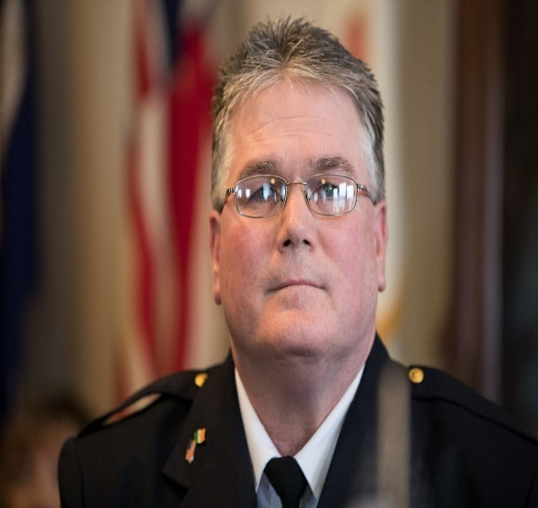
Wilkes-Barre police Chief Joseph Coffay said his department actively seeks minority applicants by reaching out to local colleges and by employing a community police officer.

Wilkes-Barre Police Chief Joseph Coffay said his department actively seeks minority applicants by reaching out to local colleges as well as employing a community police officer. “This department is the only department in the area which has a community policing officer who assists with social events and recruitment,” Coffay said. “We have attended job fairs, colleges and numerous public events to recruit officers. This is in addition to individual officers taking it upon themselves in their daily dealing with the public to identify and recruit officers. The department has reached out to any and all candidates within the local college system and have specifically recruited minority candidates and ask them to take the test.”
Coffay said the department has also reached out directly to advocacy groups in an effort to recruit minorities. “We’ve reached out to the NAACP. We’ve reached out to the Spanish newspapers,” Coffay said. “One of the other things we do is we don’t restrict our application process to just Wilkes-Barre residents. Some people might want us to do that, but it kind of narrows your pool of applicants.”
One advocate for requiring police to reside in the city is Gilbert McBride. “Mandating our police to live in our city would also help to increase representation,” Gilbert McBride said. “Right now, only 24% of our officers are city residents. Officers are hired by the city, and their tax dollars go to other municipalities.”
Gilbert McBride also said she believes there are “systemic issues” with the police civil service exam, including a $100 application fee, which she described as “way too high to get a diverse pool of applicants.”
Jirau, the community activist, said he has worked closely with many local departments, including Wilkes-Barre, and that he believes Coffay and Mayor George Brown are actively working to diversify the force.
“We need more diversity, yes we do,” Jirau said. “Are they working at it? All I know is that the people I’ve contacted, especially the Wilkes-Barre police, they make every effort that I know to reach out.”
Bohn, of the Pennsylvania Chiefs of Police Association, said departments can take steps to improve their recruitment practices by expanding advertising beyond their immediate jurisdictions.
“They should be very active in their recruitment and perhaps expanding their footprints, not only in their local areas but in a larger area,” Bohn said. “Advertising in a statewide organization or association to attract a larger number of qualified candidates, regardless of their color.”

Proven tactics
Officials in similarly sized communities that have had more success attracting minorities credit their efforts to look outside the box.
Reading significantly increased its Hispanic representation on the force after it implemented a policy in 2010 that gives applicants 10 extra points on their civil service examination if they are fluent in Spanish. It also formed a police diversity board.
Today the force is 13.7% Hispanic compared to 6.3% in 2003. African American representation also increased from to 7.9% of the force, compared to 1.6% in 2003.
Sgt. Mel Fegley, administrative assistant to Reading’s police chief, said there was some push back regarding giving extra points to candidates who are fluent in Spanish. That has largely diminished now that the benefits of having a larger Hispanic presence on the force has become clearer.
“It helps on two fronts. When a crime just happens you need witness accounts. If you don’t have Spanish speaking officers it hampers how quickly we can get to work,” Fegely said. “On the community side, having someone who speaks Spanish makes them feel they understand were they are coming from.”
It’s not clear if other cities can give additional credit to Spanish speaking candidates. Reading implemented the programs as part of a settlement of a 2003 lawsuit filed the Pennsylvania Statewide Latino Coalition that challenged its hiring policies.
Contact the writer:
jhalpin@citizensvoice.com
570-821-2058
tbesecker@timesshamrock.com
570-348-9137

