Edgeworth chief John English tapped to lead Pa.’s Chiefs of Police Association

TONY LARUSSA | Wednesday, August 26, 2020 4:46 p.m.

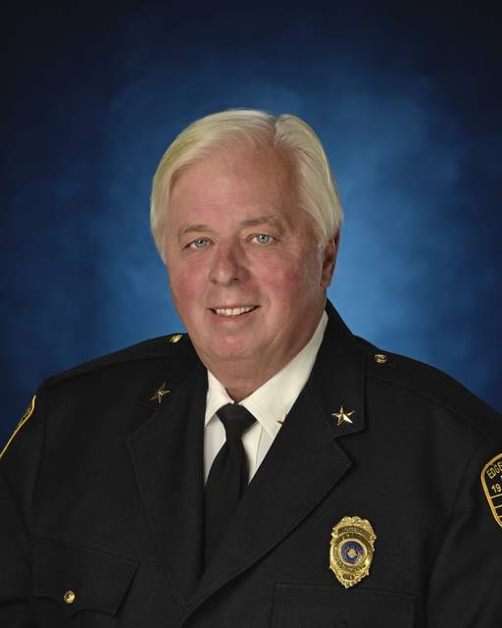
COURTESY OF PENNSYLVANIA CHIEFS OF POLICE ASSOCIATION
Edgeworth police Chief John English has been elected to a one-year term as president of the Pennsylvania Chiefs of Police Association.

TribLIVE's Daily and Weekly email newsletters deliver the news you want and information you need, right to your inbox.
A police chief from Allegheny County with nearly five decades of law enforcement experience has been elected president of the Pennsylvania Chiefs of Police Association.
Edgeworth police Chief John English, 72, was sworn into the state leadership position July 14 by Dauphin County Judge Edward Marsico.
“Chief English has the knowledge and experience,” said Scott Bohn, the association’s executive director. “We look forward to working with Chief English, our executive board and members.”
The challenges of taking on a leadership role with a law-enforcement organization in the wake of the George Floyd incident in late May are not lost on English, who will have to work to counter the negative image of police caused by the actions of a handful of officers.
“One of the big things that came out of that is how one incident can turn a whole profession from being the good guys to being the bad guys almost overnight,” English said. “There have been ups and downs for the profession over the years, but this is the most bizarre thing I’ve seen in my 46 years of doing this.”
English, who spoke while traveling to Harrisburg to testify before a state House committee on law enforcement, said the tarnished image of police officers caused by “the few bad apples” could make it difficult to recruit strong candidates in the future.
“A lot of police officers, especially in big cities, are exiting,” he said. “And there are not a lot of people lining up to get in, which I think will result in some bad consequences.”
English said he also takes issues with the current belief among some that “almost every police department is abusing people of color.”
“This is not the case and far from the truth,” he said. “I’d say that 99% of the officers I’ve known do the right thing. But all it takes is a video like the one of George Floyd for people to say ‘all police are out of control.’ The reality is, that officer was out of control. There are bad people in every profession, so it’s unfair to paint all police with the same brush when something like that happens.”
English, a native of Sewickley Heights who began working for the West Palm Beach Police Department in 1974 and rose to the rank of commander there, said recent calls across the country to defund police departments demonstrate a narrow view of who the police serve.
“My zone while working in Florida was a really bad, extremely violent area,” he said. “But what I learned during the years I spent down there was that it was also a great community that had nice mom and pop stores, churches and good people. But all that was overshadowed by the violence. Those are the people the police are there to serve.”
English initially moved to Florida to work in the aerospace industry, but decided to join the “family business” — law enforcement — because of a lack of steady work.
The chief’s father retired as a lieutenant from the Sewickley Heights police department and several other family members had careers in law enforcement.
He moved back to Pennsylvania after retiring from West Palm Beach and was hired in 2001 as Edgeworth’s police chief.
English said local government, police departments and individual officers share the responsibility for ensuring police act professionally — especially now, when their interactions with the public are likely to be filmed.
“Perception is reality,” the chief said. “I tell my people that whenever you have that uniform on, everybody is looking at you and everybody’s got a camera. So you have to be aware and more careful about what you do.”
Local governments also can ensure that its police officers receive proper training by requiring their departments go through the process of becoming accredited by the state.
“We’ll be trying to get as many police department as we can in the state accredited,” said English, who will serve a one-year term as president. “Even municipalities that can’t afford to do it, or think they are too small, can get updated policies and procedures from the association to make sure they are doing things the right way.”
In addition to his work as a police officer, English attended the FBI Academy in 1991 and currently serves on the executive board of the Western Pennsylvania Chiefs of Police Association, the executive board of the FBI Academy Association of Western Pennsylvania and on the advisory board of Pittsburgh Technical College.
LaRussa is a Tribune-Review staff writer. You can contact Tony at 724-772-6368, tlarussa@triblive.com or via Twitter .

