Police reform measures to get hearing in Pennsylvania Senate

DEB ERDLEY | Friday, June 12, 2020 4:03 p.m.
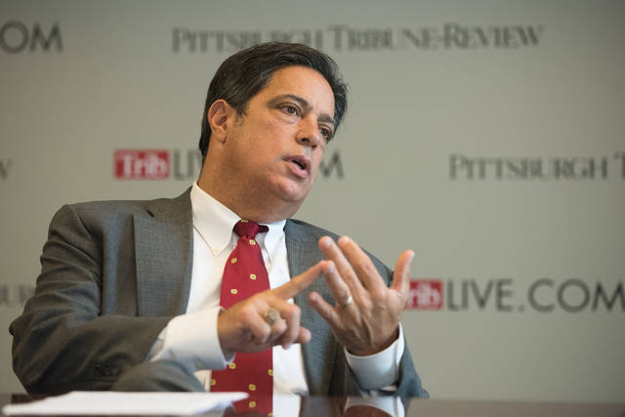
TRIBUNE-REVIEW FILE
Senate Minority Leader Jay Costa, D-Forest Hills

A bill that called for sweeping reforms in police hiring and training following the 2018 police shooting of 17 year-old Antwon Rose II in East Pittsburgh is among police reform measures that will go before a joint hearing of the state Senate Law and Justice and Judiciary committees Tuesday.
Senate Minority Leader Jay Costa, D-Forest Hills was the prime sponsor of Senate bill 458. Costa said the bill would establish a database of police misconduct incidents, beef up training for municipal police officers and require municipal police forces to adopt consistent use of force policies. The bill has been in committee for two years after encountering opposition from various police groups.
“We have about 20 bills on these issues that were locked up in committee because these organizations and the majority party opposed them,” Costa said.
Costa said state House members Austin Davis, Jake Wheatley, Dan Miller, Ed Gainey and Summer Lee — all Allegheny County Democrats — were among those who support his bill.
Public outrage over the George Floyd killing in Minnesota and Pennsylvania Attorney General Josh Shapiro’s recent effort to form a coalition dedicated to ending interdepartmental hiring of officers with histories of excessive violence renewed interest in reforms in Pennsylvania, Costa said.
He said Shapiro’s efforts have had a major impact in bringing the issue that now enjoys bipartisan interest to the floor.
Over the last week, Shapiro brought together law enforcement and union leaders from across the state to join in support of interdepartmental police hiring reforms. The reforms, outlined in Costa’s bill, have been called for by experts and grassroots community groups as well as the State Legislature Police Reform Working Group, and have recently been introduced at the federal level.
Friday, the Pennsylvania Chiefs of Police Association formally joined Shapiro’s coalition that already included Philadelphia Police Commissioner Danielle Outlaw, Pittsburgh Police Chief Scott Schubert, FOP Lodge 5 President John McNesby, President of the Pennsylvania State Lodge FOP Les Neri, the Pennsylvania District Attorneys Association and several leading municipal police chiefs.
Scott Bohn, Executive Director of the Pennsylvania Chiefs of Police Association, said his group has long supported a statewide registry that would permit police departments to certify their hiring practices.
Shapiro’s coalition issued a statement in favor of a police database, saying officers who engage in misconduct erode trust in law enforcement.
“When they leave an agency, or retire in lieu of termination, that record needs to go with them. We stand united in calling for reform of the hiring process so that law enforcement agencies have the information to make informed decisions about the personnel they hire,” the group said.
Deb Erdley is a Tribune-Review staff writer. You can contact Deb at 724-850-1209, derdley@triblive.com or via Twitter .

